ANALYZING THE CHOSEN PROBLEM:
"The important thing for the government is not to do things which individuals are already doing, and to do them a little better or a little worse, but to do those things which at present are not done at all." - Keynes
India carries the largest burden of anaemia globally. According to National Family Health Survey (NFHS-4) data, 69.9% of children in Jharkhand are anaemic. Moreover, only 17.3% of children were given iron supplements in the past week. Infectious diseases are linked to the high prevalence of anaemia. Since health is the root of productivity and national product, we have chosen this policy area to assess the scope of government intervention.
The market failure here is a negative externality. Anaemic children face impaired cognitive development, reduced physical capacity, and increased vulnerability to infections. This damages human capital formation and productivity. Economic research on reducing anaemia has generally focused on two main reasons:
- Poor nutrition [In Jharkhand, according to three anthropometric indices of nutritional status(taking mean Z scores): -1.7%, -1.4% and -1.9% children are malnourished ]
- Malaria [according to the Jharkhand govt report, more than 50% of child deaths occur due to malaria, diarrhoea, etc]
Data source: NFHS-4
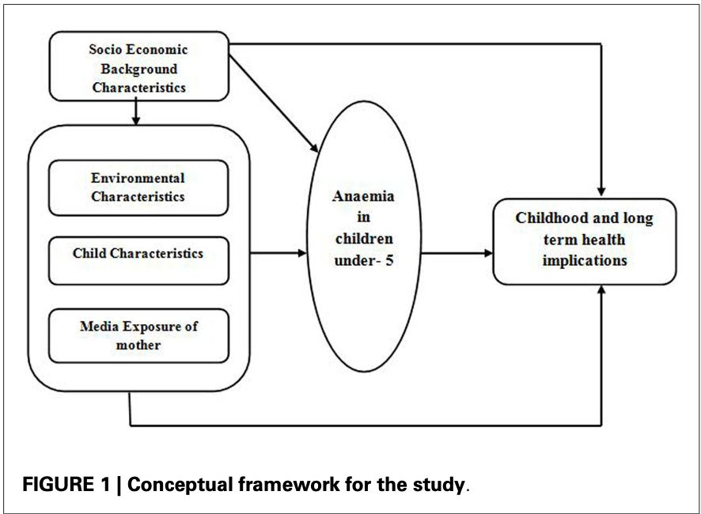
Data source: (Baranwal et al., 2014)
Private healthcare and food companies often prioritise urban centres with higher income levels (ergo higher disposable income) and better infrastructure, thus overlooking the needs of areas such as rural Jharkhand.
The quote by Keynes perfectly encapsulates the need for govt intervention in tackling childhood anaemia in rural India through public awareness campaigns, subsidies and targeted distribution, strengthening healthcare infrastructure and micronutrient fortification. Like in Jharkhand, the Hon'ble CM Hemant Soren launched a flagship initiative on December 29, 2021 - SAAMAR (Strategic Action for Alleviation of Malnutrition and Anaemia Reduction) - to improve the status of malnutrition and anaemia among children, pregnant women and lactating mothers through:
- Active involvement of Community leaders, schools, village folks and other concerned bodies in implementing the initiative and spreading awareness of nutrition
- POSHAN Dal (Anganwadi Worker (AWW), Accredited Social Health Activist (ASHA) worker, and Self-Help Group members using app-based data collection tools to collect data for the identification of malnourished children and women suffering from anaemia.
Data source: (Angad, 2021)
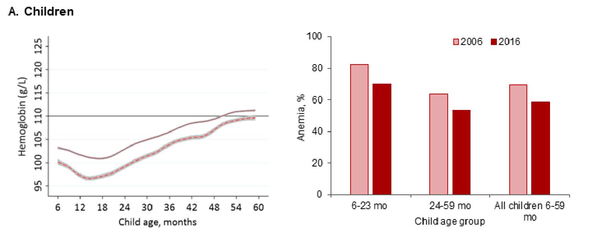
Data source: (Nguyen et al., 2018)

ANALYSIS OF OTHER PROBLEMS:

- Free sanitary pads in rural areas of J&K-

NABARD launched the project My Pad My Right initiative in the Kokernag area of Anantnag to help women with their menstrual hygiene implemented by Women's Self-help groups. The project aims at providing all the necessary materials for the production of sanitary napkins on a grant basis. But some of the failures of this initiative were,
- The pad-making machines required initial capital investment to cover maintenance and depreciation costs
- Menstrual hygiene is regarded as a taboo therefore making it harder to introduce newer products to culturally conservative places like rural areas of Kashmir

Data source: (TIMESOFINDIA.COM, 2023)

The private sector might have an incentive to contribute to such initiatives under their CSR requirements. However, relying solely on private businesses for free distribution creates uncertainties, as their commitment can fluctuate based on financial constraints or changing priorities. The issues of accessibility, especially in remote areas or marginalised communities also arise.

- Nutrition distribution of food grains –
The distribution of food grains is a fairly vast policy area. To improve the efficiency and efficacy of the scheme, it is important to be specific in its implementation. The main goal behind improving access to food grains is to provide individuals with better nutrition. The anaemia policy area discussed earlier aims to alleviate the same problem with a targeted approach.
The private sector finds no short-term profit in providing free food grains to the general public and hence has no incentive to intervene. Thus the welfare state must contribute.
Data source: (Ghosh, 2022)
3. Renewal of driving licences should be more frequent –
Rampant forgery of government documents occurs due to the convenience and widespread availability of such services. Individuals may resort to paying off people to create a fake driver’s licence to get certified as renewing it every few years would be a hassle. Due to this hassle, individuals may choose to avail public transportation services rather than own private vehicles. This would lead to the government incurring further costs on infrastructure for strengthening the public transport system as the current one is far from ideal and provides low connectivity. The private sector has no incentive to provide such services due to lack of profit the corporations can make. Another reason is there is a higher chance of corruption when official documents are provided by private entities rather than a government body.
Data source: (Sun, n.d.)
4. Reducing the number of people working in the unorganised sector-
The Informal sector workers face a deficit of formal contracts, paid leave, and social security benefits. This makes up for labour at meagre wages for the private sector, cutting down on their costs, and leaving them with incentives to invest. The government has taken initiatives by launching the E-shram portal. It registers the non-contractual workers. Uttar Pradesh and Bihar are the two states that provide the largest number of workers to the informal sector. The Period Labour Force Survey of 2020-21, shows that nearly 81.4% of the population in Uttar Pradesh and 94% population in Bihar contributes to the informal unemployment rate. The informal sector workers face exploitation due to the lack of complete information thus leading to a market failure.
5. Free goods distributed by govt before elections-
The promise of irrational freebies from public funds before elections influences the voters. Distributing free goods can distort market prices and resource allocations. In recent years Tamil Nadu had a case in the Supreme Court. Even though the court agreed that this practice is not corruption we believe that it hampers the market equilibrium, and acts as a positive externality but not in the long term as it will make the receivers.

